SAF Fellow - It is time to nominate members for consideration as SAF Fellows. You can nominate any MOSAF member in good standing, (No self nominations as per National SAF requirements).

The nomination process is quite involved and takes some time to complete but we will try to advise and assist as needed. To nominate, you must complete the Nomination, Consent and Endorsement forms (below). We will not need the Biographical and Professional Information form completed to nominate.

If the nominee is selected to be submitted to the District 9 Fellows Committee for consideration, they will be notified and the Biographical form must then be completed with a December 31 deadline.

Please send any SAF Fellow nominations to Mike Hoffmann at moforester1@yahoo.com, by September 30, 2017.

If more than two nominations are received, we will poll MOSAF membership to select up to two candidates for consideration. A final decision on MOSAF candidates will be made at the fall MOSAF Business meeting on October 30.

Contact Mike Hoffmann with any questions, 573-418-6221.

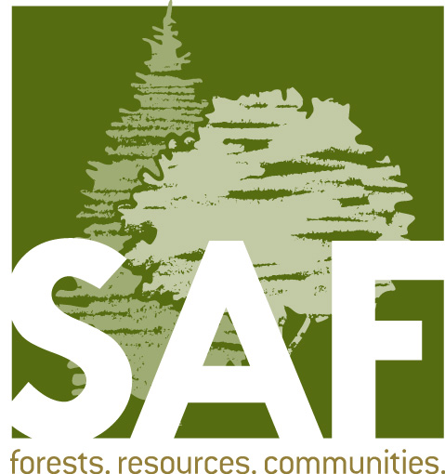

Fellow

Nomination/Consent Form

Nominations are due March 15

Email submissions are preferred; hard copy nominations
postmarked after March 15 will not be accepted.

- Nominee Contact Information/Consent:

Nominee’s name:
Address:
City: State: ZIP :
Day Phone: E-mail:
SAF Membership Number:

I hereby consent to have my name placed in nomination for Fellow. I have reviewed, find it to be accurate, and hereby approve the accompanying biographical sketch.

Signature: _______________________________ Date: _______________________

- Nominator Contact Information:

Nominator’s name:
Address:
City: State: Zip code:
Day Phone: E-mail:

As the nominator, please select which category or categories the nominee should be considered under
(see criteria for descriptions):

Application of Forestry Education Public Policy Research Technology Transfer

- Check List (your nomination packet must contain the following):
- The nomination/consent form
- Three completed endorsement forms outlining the nominee’s accomplishments
- A completed biographical and professional information form or curriculum vitae
- A recent digital photo with a minimum of 300 dpi

- Submit all nomination material via email (preferred) or mail to:
Lori Rasor
Fellows Nominations
Society of American Foresters
4033 SW Canyon Road, Portland, OR 97221
rasorl@safnet.org • 503-224-8046

Program Summary

The Fellow Award recognizes extraordinary contribution to forestry through
- a strong continuing commitment through direct SAF volunteer activities; and
- exemplary action and sustained leadership; and
- advancement of the forestry profession in at least one of the following areas: (a) application of forestry, (b) education, (c) public policy, (d) research, or (e) technology transfer.

The SAF Fellow Award is a prestigious award that recognizes an SAF member for long-standing service to forestry at the local, state, and national level. The SAF Fellow is recognized as an ambassador for the advancement of forestry.

Awardees are recognized during their local state society meetings with a certificate and receive a Fellow’s pin upon confirmation from SAF Board of Directors. All newly elected Fellows receive a ticket to the Fellow’s breakfast at the SAF National Convention.

Eligibility
- Professional Members in good standing.

Not Eligible
- Acts performed under contract to SAF, directly or indirectly, do not qualify for consideration as volunteer activities.
- Self-nomination.

Criteria for Selection
1) Significant number of years of sustained commitment to SAF volunteer activities, performed at two or more of the following SAF organizational levels: local (chapter); state; regional (multi-state or voting district); or national.
2) Exemplary action and sustained leadership over many years in advancing the forestry profession at two or more of the following organizational levels: local; regional; national; or international.

Exceptions may be made for unusually notable contributions to SAF or to the forestry profession over a shorter time frame.

Nomination Review
The District Fellows Committee will utilize a set of questions including, but not limited to, the following when reviewing the candidate’s qualifications.
  - Criterion #1
- Did the nominee serve as a recognized leader on SAF committees, boards, task forces, or editorial boards making innovative and effective contributions in the service of the profession? If so, how did the involvement impact SAF?
- Did the nominee serve as an elected officer at the local level such as chapters, divisions, state societies or national level such as working group officer, council member, SAF president, House of Society Delegates officer or Student Executive Committee? If so, how did the involvement impact SAF?
- Does the nominee collaborate with colleagues to enhance forestry through special SAF service including, but not limited to, accreditation site visit teams; convention track chairs; reviewer for journal publications; ad hoc committees; representative to HSD; Student Executive Committee; faculty advisor; working group activities; or national or local leadership training?
- Did the nominee serve as a mentor or ambassador by encouraging other members or non-members towards SAF involvement or membership?
- Did the nominee’s volunteer activities occur at two or more of the following SAF organizational levels: local (chapter); state; regional (multi-state or voting district) or national?

Criterion #2 – Exemplary Action
- Does the nominee demonstrate professionalism impacting forestry in two or more of the following levels: local; state; regional; national; or international?
- Is the nominee recognized by numerous colleagues as a passionate leader who helps to raise the profession to a higher standard?
- Did the nominee demonstrate outstanding contributions in one of the following categories:

Application of Forestry (including but not limited to)
- Uses science along with the adaptive management process to achieve landowner objectives and insure forest sustainability;
- Management intensity may range from very intensive applications to more extensive management regimes; and
- Demonstrates the ability to work with colleagues to achieve management objectives.
Education (including but not limited to)
- Demonstrates innovation in education by inspiring, producing, adapting, modifying, or developing functional and effective curriculum materials in conservation education or academic programs;
- Promotes excellence in teaching as demonstrated through the success of students; and
- Incorporates research practices in the development of curriculum and to improve teaching and student learning.

Public Policy (including but not limited to)
- Demonstrates the ability to communicate sound forest management practices to local, state, or national legislators;
- Encourages involvement of professionals in forest policy issues;
- Demonstrates the ability to impact forest policy to ensure sound forest management practices; and
- Demonstrates involvement with local or state legislative commissions or advisory boards that promote sound forest management practices.

Research (including but not limited to)
- Encourages high standards of research;
- Publishes in refereed publications;
- Shares research through presentations at professional meetings; and
- Exhibits involvement in the research of others as a subject or collaborator as dictated by the needs of the research.

Technology transfer (including but not limited to)
- Demonstrates how technology transfer activities affected the manner in which forestry is practiced;
- Demonstrates the ability to use a variety of techniques to transfer information; and
- Works with a variety of professional organizations and groups to share technical information concerned with the management of forest resources.

Nomination Procedures
Nomination material must be submitted to the SAF National Office by March 15. Nomination packets must contain all of the following documents:
- A nominations/consent form
- Three endorsement forms address the nominee’s accomplishments
- A completed biographical and professional information form, or curriculum vitae
- A recent digital photo with a minimum of 300 dpi.

Fellow candidates will be evaluated by a District Fellows Committee established in each SAF voting district.
All nomination material will be forwarded by the SAF National Office to the District Fellows Committee (DFC) for review.

All nominations the DFC deems qualified will be forwarded to the national Committee on Professional Recognition (CPR) to ensure nomination packets are complete and nomination procedures followed.

The Committee on Professional Recognition will forward nominations, as a final recommendation, to the SAF Board of Directors for approval.
Questions? Please contact Lori Rasor at 503-224-8046 or rasorl@safnet.org.

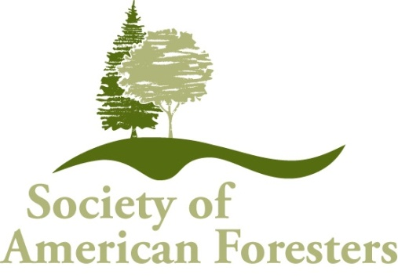
Fellow

Endorsement Form

Each nomination packet must include three endorsement forms
completed by three different individuals.

Please note: information may be provided separately if more space is required
Endorser Contact Information:
Endorser’s name:
Address:
City: State: Zip code:
Phone: (home, work or mobile) E-mail:_______
Criterion #1 - Commitment to SAF

- Provide specific examples that demonstrate the nominee’s commitment to SAF voluntary activities in two or more of the following SAF organizational levels: local (chapter); state; regional (multi-state or voting district); or national. Examples should include as much detail as possible to demonstrate the nominee’s involvement in each activity or project.

- Provide information on how SAF benefited from the nominee’s involvement in these activities or projects. Please be as specific as possible and include any and all short-term and long-term impacts to SAF.

Criterion #2 – Exemplary Action
Please select the professional activity in which the following information will cover
Application of Forestry Education Public Policy Research Technology Transfer

- Provide specific examples of the nominee’s involvement in activities or projects that advance the forestry profession at two or more of the following levels: local; regional; national; or international. Examples should include as much detail as possible regarding the nominee’s involvement or accomplishments in these activities or projects.

- Provide information on how the forestry profession benefitted from the nominee’s action or leadership in the above activities or projects. Please be as specific as possible and include all short-term and long-term impacts to forestry.

Additional Information
Please add any additional information regarding the nominee’s involvement which will assist in evaluation for Fellow.

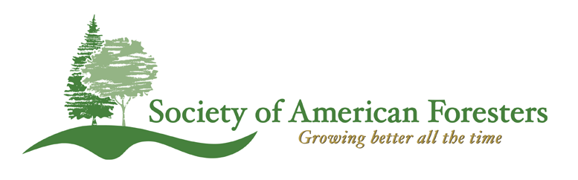
Fellow Nominations
Biographical and
Professional Information
(as of 01/20/06)

Biographical and Professional Information
Nominees for SAF Fellow
(as of 01/13/06)

Name of Nominee:___________________________________________
Date:______________________________________________________

Please complete and return this form to the District Fellow Committee.
Please list information in chronological order, starting with the most recent.

I. Information in support of the criteria – demonstrating a strong continuing commitment through direct SAF volunteer activities.

1. Year joined SAF:

2. Current Professional Position:
Title:
Employer:
City, State:
If retired, please state year retired:

3. Previous Work Experience:
List titles, employers, locations, and dates of employment.

4. Education and Professional Development:
List degrees with field, college or university, year graduated.
List any certification, licensing, or registration
List attendance at national conventions or leadership academies

5. Military service (if applicable):

6. SAF Activities and Accomplishments:
List and describe your SAF activities, accomplishments, awards and recognition by SAF level below which respond to the SAF criteria for Fellow. Within each SAF level, list information in chronological order, starting with the most recent.

National level (national level offices, committees, governing bodies, task forces, working groups, etc.):

State or multi-state level (state and regional offices, committees, etc.):

Chapter level (chapter and local level offices, activities, etc.):

II. Information in support of the criteria – exemplary action, sustained leadership, and advancement of the forestry profession in at least one of the following areas:

Application of forestry,
Education,
Public policy,
Research, or
Technology transfer

List and describe in chronological order your forestry professional activities, accomplishments, awards and recognition, which respond to the forestry profession criteria for Fellow.

III. Other Relevant Activities:
List any memberships and affiliations in other professional associations and organizations, including honorary and academic societies. List any community activities, including membership in civic organizations. List any awards (SAF or other) and recognitions.

